Beef Information Day - Cooma

Wednesday, 4 May 2016
South East Local Land Services, in partnership with Jeff House Livestock invites beef producers to attend a free beef information day at “Gunyah” near Cooma on 4 May.
Guest speaker Jeff House has worked in the beef industry for over 20 years and will be sharing his wealth of knowledge and experience.  The on-farm info day will have a particular focus on improving the output of your beef herd.  Topics will include:  - Herd management to maximise fertility  - Producing and marketing beef  - Bull selection  - Heifer selection and live animal assessment | 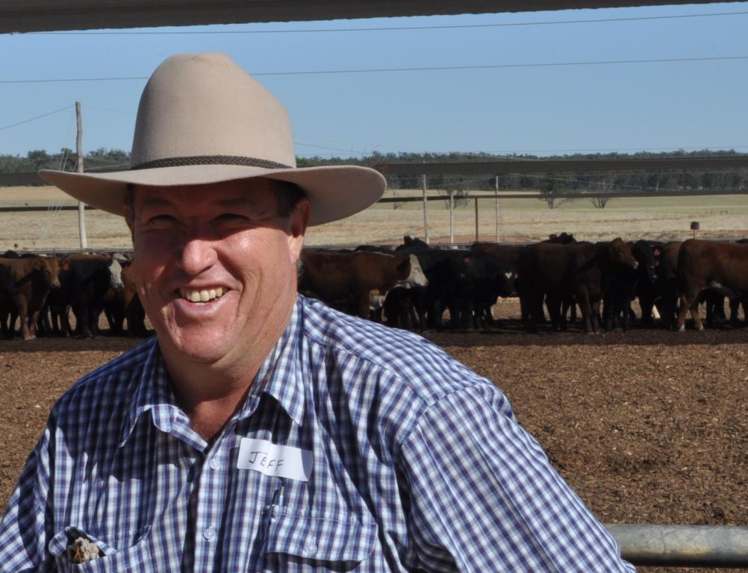
The day will include a mixture of theory and hands-on learning (see over page for the full program).
When | Wednesday, 4 May 2016
Time | 9:00am - 3:30pm
Where | Gunyah, Cooma  (further directions and information to be provided upon registration)
Cost | Free
Catering | Morning tea and lunch provided
RSVP | RSVP to John O’Connor on 0412 359 084, john.oconnor@lls.nsw.gov.au, or Jo Powells on 0429 785 986, jo.powells@lls.nsw.gov.au

BEEF INFO DAY – PROGRAM
Time | Topic
9.00am – 9.30am | General introduction, including an overview of the farm operation.
9.30am – 10.30am | Herd management to maximise fertility – fertility is a major profit driver of beef enterprises. What are the targets and how can they be achieved?
10.30am - 10.45am | MORNING TEA
10.45am - 12.15pm | Producing and marketing beef - overview of the main beef markets and specifications. What are the pros and cons of various enterprises/ target markets?
12.15pm - 1.00pm | LUNCH
1.00pm - 2.15pm | Bull selection – visual traits, structure, carcass and fertility. What EBVs should I focus on?
2.15pm - 3.15pm | Heifer selection and live animal assessment
3.15pm – 3.30pm | Wrap up

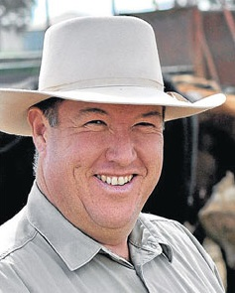 | About Jeff House…  Jeff is the principal of Jeff House Livestock, established in 2014 as a private consulting business with the aim of sharing knowledge with beef producers and the beef supply chain across Australia.  Jeff works closely with beef producers, lot feeders and processors to improve the performance of their herds and operations. Activities include on farm animal selection, feedlot feedback trials and carcase judging.  Jeff was employed in 1997 by the NSW DPI as a Beef Livestock Extension Officer and remained in this position until 2013, based out of Forbes. In this position Jeff developed and delivered extension and education programs to the NSW beef industry. These included working with beef producers in the areas of breeding, genetic selection, cattle assessment, nutrition and meat quality.

